The Explorer Gondola — A New Era of Access at Big Sky
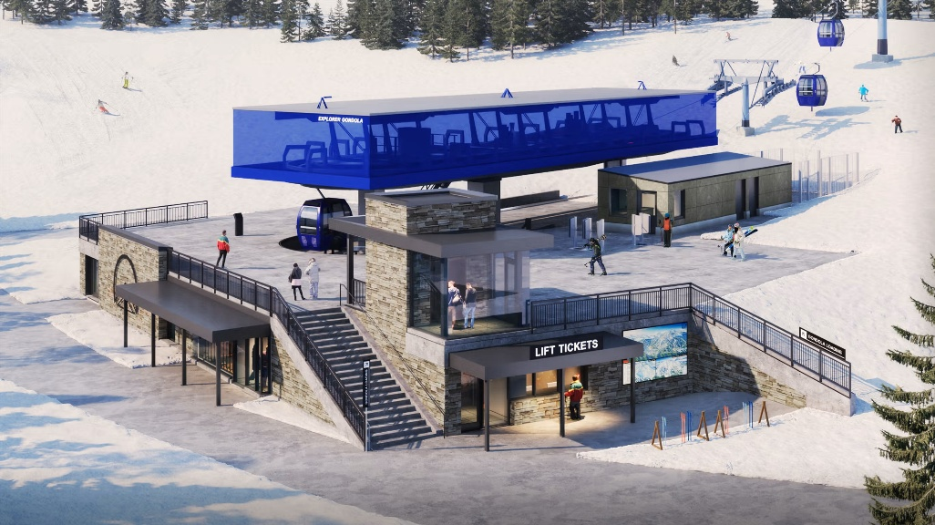
This season Big Sky will unveil the Explorer Gondola, a groundbreaking addition that redefines mountain access, comfort, and connectivity. Replacing the original 1973 Explorer chairlift, this state-of-the-art, two-stage gondola will move 3,200 guests per hour and provide seamless access from the main base area to The Bowl. By creating a vital link to the Lone Peak Tram, Explorer Gondola will unlock a true base-to-peak journey for skiers and riders of all levels.
Key Features of the Explorer Gondola:
- Two-stage lift system with mid-station access to beginner terrain, upper station access to northern Swift Current terrain and direct access to the Lone Peak Tram.
- 83 custom cabins, each seating up to 10 guests with heated ergonomic seats, floor-to-ceiling panoramic windows, interior gear holders, and exterior ski racks.
- Mid-station understructure: A 21,000 sq. ft. below-grade cabin parking and maintenance facility ensures each gondola is stored safely each evening.
- Upper terminal at the Tram base, streamlining the journey to Lone Mountain’s 11,166’ summit.
- Located in front of Huntley Lodge!
Whether you're a first-time skier or chasing expert terrain, the Explorer Gondola will revolutionize your day on the mountain. Enjoy faster access, better terrain connectivity, and a level of comfort unmatched in North American ski resorts.
This isn’t just a lift — it’s a bold step into Big Sky’s future, two years in the making, and just in time for an unforgettable 2025–26 season.
To watch construction of this transformational project, follow this link.
Shari

